Hosts Look Back On 25 Years of Adult Alternative Radio
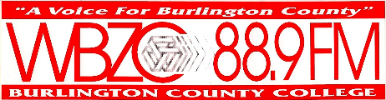
Adult alternative airplay -- dubbed Triple A -- has evolved since its debut 25 years ago to address musical trends and technological innovations, radio hosts say. A sense of community and the unique insights about songs or artists that radio hosts can provide make the format special and have helped it weather competition from other audio platforms, alternative hosts say.
Billboard 2/18/21
https://www.billboard.com/articles/business/chart-beat/9527549/adult-alternative-radio-anniversary-interview-programming-directors/
Image credit:
https://www.bing.com/images/search?view=detailV2&ccid=gM9US4tn&id=11B11A93A3A476E309D0692770930DA92B35B154&thid=OIP.gM9US4tnrlnT05cd4y41TAHaB7&mediaurl=https%3a%2f%2fth.bing.com%2fth%2fid%2fR80cf544b8b67ae59d3d3971de32e354c%3frik%3dVLE1K6kNk3AnaQ%26riu%3dhttp%253a%252f%252f1.bp.blogspot.com%252f-9YyVtyT_dxI%252fT-XDZENoInI%252fAAAAAAAAF0s%252fD5XLczIWk9U%252fs1600%252fwbzc2.jpg%26ehk%3dZYnr6uI4tWf%252fgzfDBjICtZ4P9quUliZJ8tXozT39KTQ%253d%26risl%3d%26pid%3dImgRaw&exph=417&expw=1600&q=WBZC-FM&simid=608009250645674786&ck=12533D9A25A3DB9FBD1B6B34241B71FC&selectedIndex=43&FORM=IRPRST&ajaxhist=0

