How a Station Used ‘Deep Listening’ Events to Take On Sacramento’s Housing Crisis
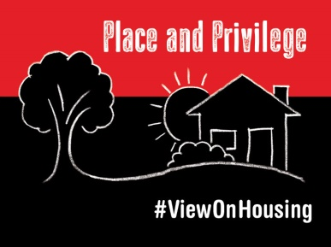
Capital Public Radio, where I work as senior community engagement strategist, responded to the crisis by spending the past year digging into the history, politics and economics of housing affordability in California’s capital. We produced The View From Here: Place And Privilege, an eight-part podcast, hour-long radio documentary and online community platform.
Current 7.17.18
https://current.org/2018/07/how-a-station-used-deep-listening-events-to-take-on-sacramentos-housing-crisis/?utm_source=API+Need+to+Know+newsletter&utm_campaign=22c6547a08-EMAIL_CAMPAIGN_2018_07_18_12_15&utm_medium=email&utm_term=0_e3bf78af04-22c6547a08-31697553
Image credit:
https://www.capradio.org/media/9458564/PlacePrivilege_hashtag_800x600.jpg

