How Bots are Evolving and When You Should Use Them
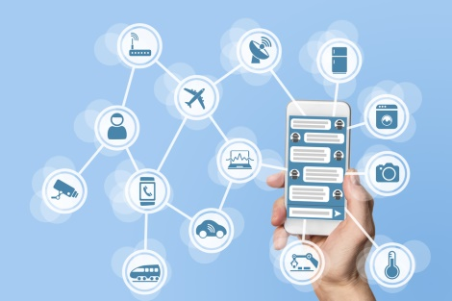
DigitalGenius' Mikhail Naumov and Autodesk's Rachael Rekart discuss how their companies are progressing with artificial intelligence to create more sophisticated chatbots that can solve customer requests or understand a customer's emotional state through facial recognition technology. Both concur that bots should be restricted to specific tasks, with Naumov advising that marketers "should use a bot for interactions that are simple, that are repetitive, and that are time-sensitive."
VentureBeat 8/21/18
https://venturebeat.com/2018/08/21/how-autodesk-and-digitalgenius-are-evolving-ai-customer-service-beyond-chatbots/
Image credit:
https://securecdn.pymnts.com/wp-content/uploads/2016/09/hey-xero-cloud-accounting-chat-bot-facebook-messenger-imessage-artificial-intelligence.jpg

