How Brands Adapt to Major Changes in American Culture
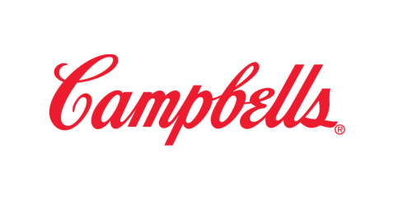
Campbell Soup's Denise Morrison identifies four trends in American culture that pose a challenge for consumer brands. The all-American family looks different nowadays, consumers want healthier options, the wealth of digital communication channels is overwhelming, and the dwindling middle class forces dual campaigns aimed at both high-income gourmet shoppers and low-income value-meal customers.
Business Insider 10/27/15
http://www.businessinsider.com/4-changes-terrifying-consumer-companies-2015-10

