How Brands are Engaging Instagram Users with Polls
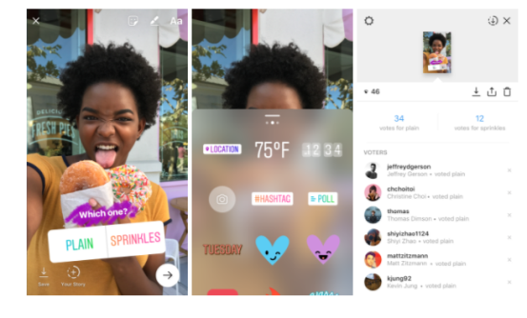
Matthew Dunn takes a look at how businesses are making the most of Instagram's new polling feature, such as the MLB and the NBA using it to create excitement about upcoming games and Discovery Communications asking audiences to share their opinions about shows. HelloFresh uses the feature to gather feedback on new recipes, and the opportunities for marketers are boundless, he writes.
Adweek 10/26/17
http://www.adweek.com/digital/matthew-dunn-arnold-worldwide-guest-post-instagram-polls/
Image source:
http://www.childnet.com/uimages/Blogs/2017/Instagram_polls.png

