How Brands Can Leverage Influencers On TikTok
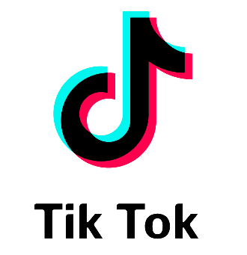
Influencer marketing is booming on TikTok and agency executives share their views on how brands are most effectively engaging with the platform's audiences. "The experimental nature of TikTok and the general levity that exists in-platform means that brands are able to get more creative and feel less pressure to deliver polished content for their audience," says The Wild's Tom McGirr.
The Drum (free registration) 4.8.21
https://www.thedrum.com/news/2021/04/08/the-stage-set-brands-jump-tiktok-s-influencer-marketing-boom

