How Brands, PR Shops are Investing in Social Media Damage Control
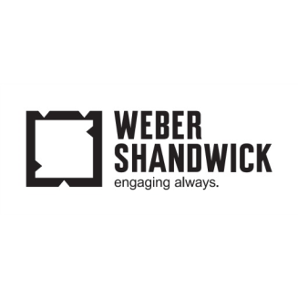
Brands such as Carl's Jr. and Hyatt and PR companies such as Weber Shandwick are taking measures to avoid social media disasters, such as those experienced recently by Pepsi and United Airlines, by ensuring that staff members are monitoring social in real time or by creating simulation exercises to practice responses to possible social backlashes.
The New York Times 4/13/17
https://www.nytimes.com/2017/04/13/business/media/united-and-pepsi-affairs-force-brands-to-respect-social-media.html?WT.mc_id=SmartBriefs-Newsletter&WT.mc_ev=click&ad-keywords=smartbriefsnl&_r=0

