How Digital is Transforming Political Campaigning
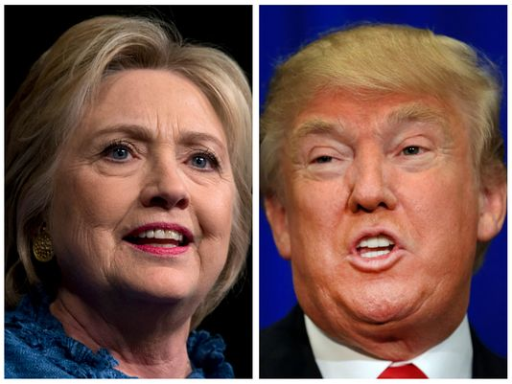
Digital advertising for this year's presidential campaigns is estimated to hit $1 billion by November, double the investment made in online ads in the past four elections combined, writes Robert Gebelhoff. The internet is transforming political campaigns as candidates capitalize on a cheap, targeted and effective way to engage with mass audiences.
The Washington Post 8/8/16
https://www.washingtonpost.com/news/in-theory/wp/2016/08/08/how-will-the-internet-change-political-advertising/?wpisrc=nl_sb_smartbrief

