How Facebook, Twitter Helped Lead Trump to Victory
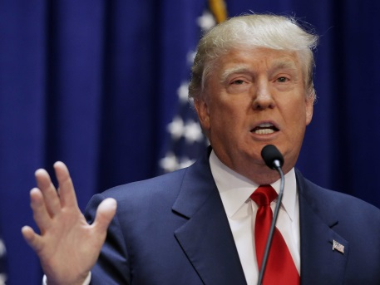
Facebook will have to contend with mounting dissatisfaction over its role as the most widely used news filter in history. Echo chambers on Facebook may have helped Trump win, but Twitter gave him a way to reach American voters constantly and without an editor.
Advertising Age 11.9.16
http://adage.com/article/digital/facebook-twitter-played-a-major-part-trump-s-win/306699/?utm_source=daily_email&utm_medium=newsletter&utm_campaign=adage&ttl=1479354904?utm_visit=113450
image source:
http://static2.businessinsider.com/image/55805fececad046633bc01aa/donald-trump-got-only-8-words-into-his-campaign-before-we-found-a-seriously-questionable-fact.jpg

