How HBO Is Changing Sex Scenes Forever
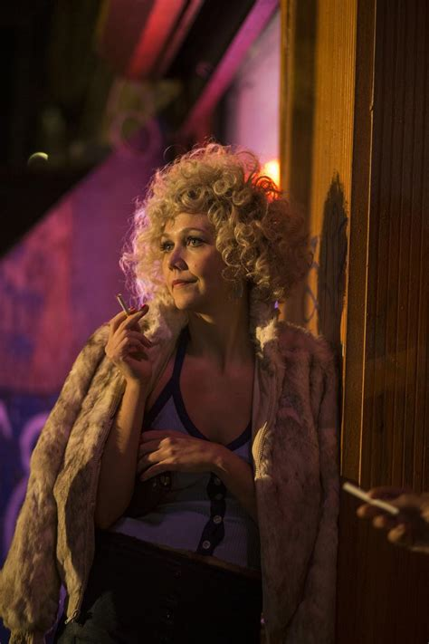
In the wake of #MeToo, the network hired an intimacy coordinator to make the filming of sex scenes on ‘The Deuce’ safe for all. Now, they’re doing it for every show and movie they produce. Network executives found Alicia Rodis through Intimacy Directors International, a nonprofit she cofounded in 2016 that aims to normalize a set of standards and practices surrounding the execution of sex scenes on stage and on film
Rolling Stone 10.24.18
https://www.rollingstone.com/tv/tv-features/the-deuce-intimacy-coordinator-hbo-sex-scenes-739087/
Image credit:
https://www.ibtimes.com/sites/www.ibtimes.com/files/styles/embed/public/2017/09/20/maggie-gyllenhaal-candy.jpg

