How Nintendo Works With Influencers
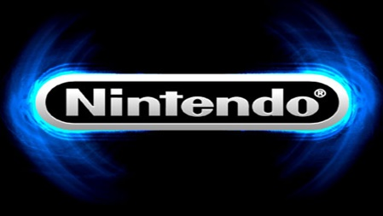
Nintendo's influencer strategy includes ensuring that a collaborator's personality is a good fit for the brand and current campaigns. The company also gives influencers a good grounding in campaign strategy and listens to what they have to say about what appeals to their specific audience.
SmartBrief/Social Media 7/6/16
http://www.smartbrief.com/original/2016/07/andy%E2%80%99s-answers-nintendo%E2%80%99s-tips-and-tricks-creating-effective-influencer?utm_source=brief

