How PR Pros Can Best Engage with LGBTQ Community
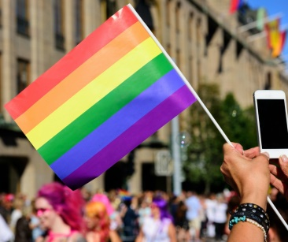
Annual Pride events have been canceled due to the coronavirus pandemic, but communications professionals can still engage with this community, which represents $1 trillion of buying power, Agency 33's Joey Amato writes. He suggests using local advertising platforms, designating an LGBTQ liaison and supporting related charities and notes, "companies who show support to the LGBTQ community during times of crisis will be the ones who will benefit the most when business returns to a sense of normalcy."
PRSAY 6.15.20
http://prsay.prsa.org/2020/06/15/3-ways-to-reach-lgbtq-consumers-in-the-new-normal/
Image credit:
https://marketingweek.imgix.net/content/uploads/2017/04/04152326/iStock-509663632_LGBT_1040.jpg?auto=compress,format,&crop=faces,entropy,edges&fit=crop&q=60&w=1240&h=1040

