How Radio is Shaping Up to be the Future of Music
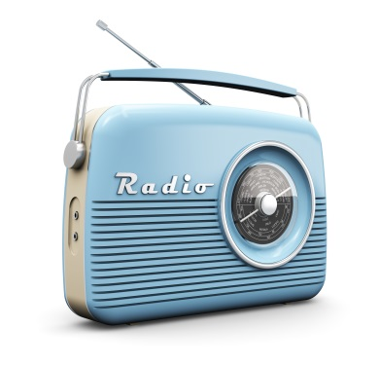
Over 90% of US consumers tune in to AM/FM radio each week, and it is the top source for discovering new music. NextRadio President Paul Brenner says that "[i]n the old days a radio station was the frequency you tuned into for a programmer's choice of airwaves. Now it could be a playlist somebody created, or a pre-programmed genre channel."
Quartz 10/11/17
https://qz.com/1094963/radio-survived-the-tape-cd-and-ipod-in-the-age-of-spotify-its-more-popular-than-ever/
Image credit:
http://az616578.vo.msecnd.net/files/2016/01/30/635897728052078191555035650_bigstock-Vintage-radio-58711064.jpg

