How Social Listening Improves Your Brand
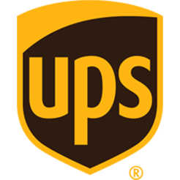
People who complain on social platforms give brands a chance to listen and genuinely improve, says Vincent Washington, social media manager at UPS. Since taking over, Washington has shifted his team's focus from reactive to proactive social listening.
SocialMedia.org's Blog 8/9/16
http://socialmedia.org/blog/vincent-washington-on-proactive-social-listening-at-ups/

