How to Spot a Deepfake Like The Barack Obama–Jordan Peele Video
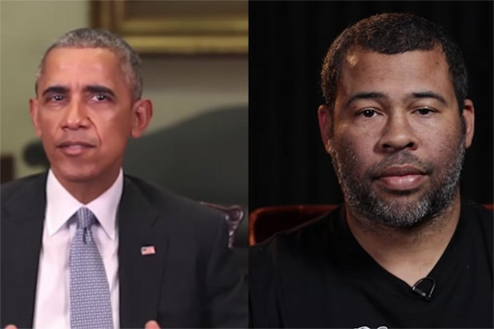
Part of the process for creating this video involved taking an original video of Barack Obama and pasting Jordan Peele’s mouth into it. It looked really bad and clumsy at first. But things got remarkably better the longer FakeApp was left to process a more believable amalgamation of Obama’s head and Peele’s mouth. That took roughly 56 hours and was overseen by a video effects professional.
Buzzfeed 4.17.18
https://www.buzzfeed.com/craigsilverman/obama-jordan-peele-deepfake-video-debunk-buzzfeed?utm_term=.jbq6rKVYz#.dkJXQgb3W
Image credit:
https://www.thewrap.com/wp-content/uploads/2018/04/Jordan-Peele-Obama-Buzzfeed.jpg

