Expert: Humans Must Stick Their Necks Out To Make AI Work
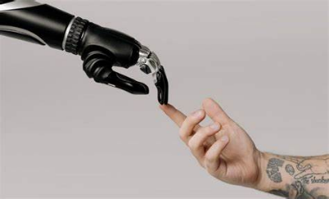
A rare non-spotted giraffe showed how artificial intelligence produces probable, not necessarily accurate, responses. Technology expert Janelle Shane says that AI is best suited for narrow, well-defined tasks, and humans are still necessary to provide empathy, expert knowledge and moral judgment.
SmartBrief/Technology 9.15.23
https://corp.smartbrief.com/original/2023/09/janelle-shane-on-giraffes-rulers-onesies-and-ai?utm_term=A25693A1-51B6-4112-BDE4-56BD420E983F&utm_campaign=9A6B83EA-211A-4D95-9BF3-DEC352898000&utm_content=74DEDDDD-8E0E-4647-8C63-66D26D491138&utm_source=brief
Image credit:
https://readwrite.com/wp-content/uploads/2023/08/Humans-and-Machines-825x500.jpg

