IAB NewFronts Focus on Streaming and Consumer Demand
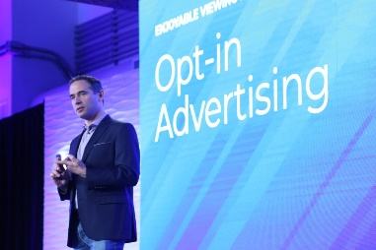
Amazon, A+E Networks, Entercom, Estrella Media, Penske Media and Vizio are first-time presenters and among the more than 30 presenters for the annual IAB NewFronts, May 3 to 6. IAB CEO David Cohen said this year's theme is "living the stream" and, "This new reality ... demands a reset of how video is bought, sold, measured and optimized."
Fierce 3.18.21
https://www.fiercevideo.com/video/amazon-vizio-among-first-time-iab-newfronts-presenters
Image credit:
https://www.iab.com/wp-content/uploads/2019/04/2019-newfronts-173-1024x683.jpg

