IATSE Rank-And-File Authorizes Strike
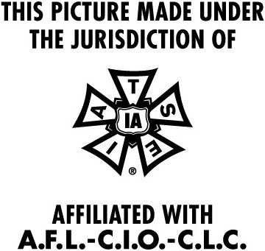
The International Alliance of Theatrical Stage Employees has authorized union leadership to call for a strike unless the Alliance of Motion Picture and Television Producers and the union can resolve their ongoing negotiations. More than 90% of the IATSE's members voted to allow the strike, which would put a halt to much of the nation's television and film production.
Variety 10/4/21
https://variety.com/2021/film/news/iatse-strike-vote-result-1235079382/

