IBM Gives Employees the Tools to be Brand Ambassadors
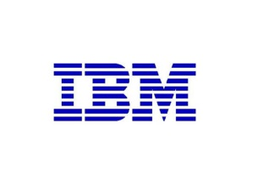
IBM has been working with Dynamic Signal to create a Social Hub and Influencer Hub, where employees can access shareable content and distribute it via their social media accounts. Around 1,000 employees have taken part, with content being distributed on LinkedIn, Twitter and Facebook. One of the company's business-to-business campaigns gained 120 million online impressions with help from employees.
Adweek 7/1/15
http://www.adweek.com/news/technology/how-ibm-got-1000-staffers-become-brand-advocates-social-media-165664

