Imagining the Television Landscape of the Future
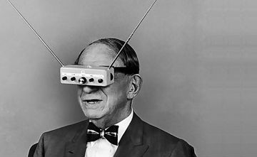
In just a decade, digital video has transformed the way we watch television. Some people even prefer it to traditional TV these days, because of its flexibility and portability. Over the next decade, another transformation will take place, and television will undergo tremendous changes once more. Digital video will play a large role in this, but other factors will also come into play as well.
MediaLife 8/30/16
http://www.medialifemagazine.com/imagining-television-landscape-future/

