Miami Murrow Winner Highlights Importance Of News Radio
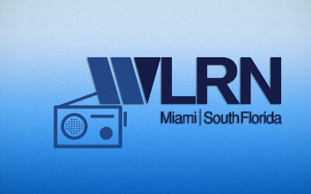
The news department at Miami, Fla., station WLRN has grown to provide its audience with fact-based news and vibrant storytelling amid the rise of more sensationalistic journalism, says general manager John Labonia, whose station won the Edward R. Murrow award for overall excellence in recognition of its pandemic coverage. The entire station's commitment to the community and shared vision was key to achieving the Murrow honor, Labonia adds.
Radio Ink 8.20.21
https://radioink.com/2021/08/20/5-questions-with-a-murrow-winner/

