In China, Brands Are Casting More Two-Child Families in Ads
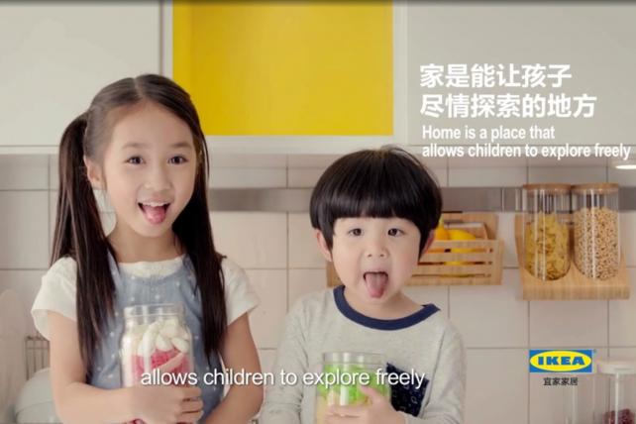
Now that China's one-child policy has officially become a two-child policy, brands including Ikea, Volkswagen, real estate developers, and airline and travel companies are jumping on the trend with ads featuring two-child families.
Advertising Age 8.16.16
http://adage.com/article/creativity/china-brands-casting-child-families-ads/305450/?utm_source=daily_email&utm_medium=newsletter&utm_campaign=adage&ttl=1471906548

