In Gaming, Mobile Phones Are the No. 1 Device By A Long Shot
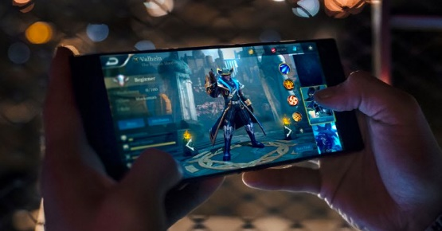
We expect there will be 159.1 million monthly mobile phone gamers in the US this year, up 1.2% from 2020. That’s 89.5% of all US digital gamers, making mobile phones the leading device by a significant margin.
eMarketer 3.31.21
https://www.emarketer.com/content/mobile-phones-are-most-popular-gaming-device-by-long-shot?ecid=NL1009
Image credit:
https://cdn1.productnation.co/stg/sites/3/best-gaming-phone-singapore.jpg

