In Iraq, the Best Digits Cost a Mint
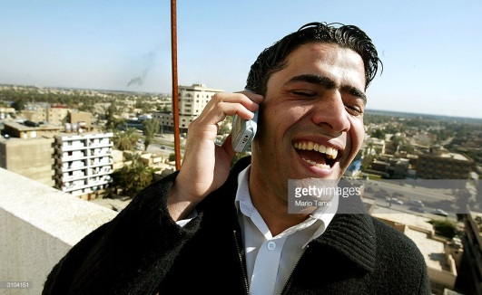
This key that opens so many doors is a cellphone SIM card. But not just any SIM card. It must be “distinguished,” associated with a phone number considered prestigious because it has a distinctive or beautiful series of digits. Say, for instance, a string of sevens or zeros, or a repeating pattern of numerals.
The Washington Post 2.13.18
https://www.washingtonpost.com/news/world/wp/2018/02/13/feature/trade-a-lexus-for-a-prestigious-phone-number-in-iraq-the-best-digits-cost-a-mint/?utm_term=.281b9d6604f3
Image credit:
http://media.gettyimages.com/photos/an-iraqi-man-tries-out-a-new-cell-phone-after-cellular-service-began-picture-id3104151

