In Mexico, ‘it is the State, Not the Cartels, that Poses the Biggest Threat to Journalists’
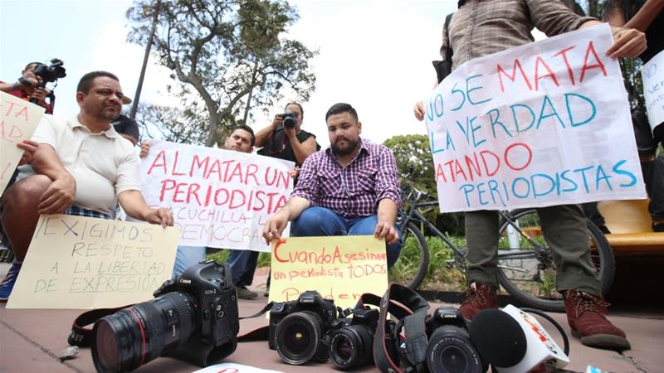
In a January 2017 investigation, Reporters Without Borders called Veracruz “the most violent state in the most violent country in Latin America,” but came to the conclusion that “it is the state, not the cartels, that poses the biggest threat to journalists.” The RSF report detailed 19 cases of reporters murdered in the last six years. Few of them had ever written about the drug war. Almost all were on the record criticizing local politicians.
Columbia Journalism Review 9.20.17
https://www.cjr.org/the_feature/mexico-journalists-cartels.php?Daily
Image source:
https://greenwatchbd.com/wp-content/uploads/2017/05/Mexican-journalists-protest-after-the-killing-of-three-of-their-colleagues-in-March-File.-EPA.jpg

