In The Streaming World, Film Libraries Lose Their Value
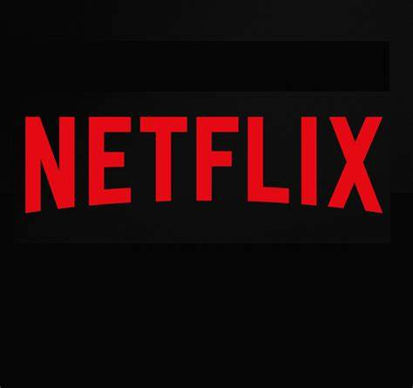
The advent of streaming has lowered demand and the value of older films, especially beyond their initial runs, as audiences increasingly prefer newer fare, industry executives say. They point to the diminishing number of older titles in Netflix's catalog, and examine how the COVID-19 pandemic has spurred changes to business models.
Variety 2.28.22
https://variety.com/2022/film/awards/digital-impact-on-showbiz-models-1235190712/

