In The Weeks After El Paso and Dayton, Mass Shooting Rumors Spread on Snapchat and iMessage
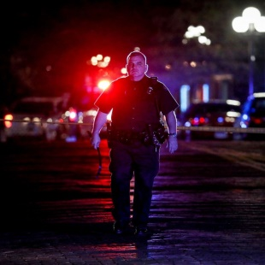
Unlike a lot of hoaxes about mass shootings, which gain steam through shares on Facebook and Twitter, rumors about additional shootings have spread on private messaging apps like Apple iMessage and Snapchat over the past few weeks. Many of those hoaxes were screenshotted and posted to more public social media platforms, where they got more attention.
Politifact 8.26.19
https://www.politifact.com/truth-o-meter/article/2019/aug/26/weeks-after-el-paso-and-dayton-mass-shooting-rumor/?utm_source=Daily+Lab+email+list&utm_campaign=9b32e363eb-dailylabemail3&utm_medium=email&utm_term=0_d68264fd5e-9b32e363eb-396123901
Image credit:
https://s.abcnews.com/images/US/dayton-shooting-cop-mo_hpMain_20190804-052658_1x1_992.jpg

