India Woman Set on Fire on Her Way to Rape Case Hearing
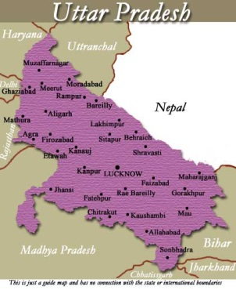
The woman was on her way to a hearing in the case she filed against two men in March, in Uttar Pradesh state. She is in critical condition in hospital, where she is being treated for severe burns. Five men including two of her alleged rapists have been arrested on suspicion of setting her on fire, police say.
BBC News 12.5.19
https://www.bbc.com/news/world-asia-india-50641606?utm_campaign=the_daily_202&utm_medium=Email&utm_source=Newsletter&wpisrc=nl_daily202&wpmm=1

