Influencer Marketing Trends on the Horizon
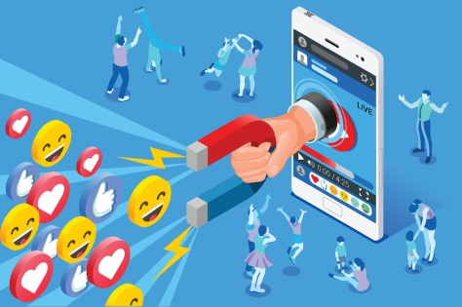
Writer Ben Jeffries believes 2020 will be a big year for change in influencer marketing and predicts more long-term branded partnerships, a rise in repurposed creator content and advances in related technology and analytics. He also forecasts an increased reliance on a balance of micro- and macroinfluencers, more partnership transparency, a rise in video content and notes brand purpose will be essential as consumers seek companies that emulate their values.
The Drum (free registration) 12/13/19
https://www.thedrum.com/opinion/2019/12/13/seven-predictions-influencer-marketing-2020
Image credit:
https://geomarketing.com/wp-content/uploads/2018/07/Influencer-Marketing-In-Action.jpg

