Infographic: Why You Should Consider Nano-Influencers
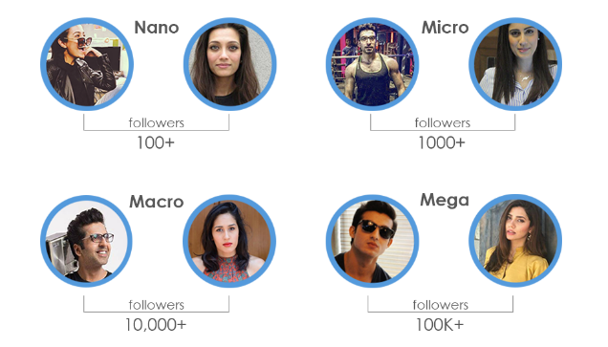
This infographic from Planoly displays facts about nano-influencers and explains why marketers should be working with them and how to find them. The visual shows nano-influencers have the highest engagement rate of any influencer category at 7%, and their benefits include close relationships with audiences and trustworthiness.
Social Media Today 2.14.21
https://www.socialmediatoday.com/news/nano-influencers-who-are-they-and-how-to-work-with-them-infographic/595048/
Image credit:
https://inflowlabs.com/wp-content/uploads/whyinfluencerfeaturer4.png

