Instagram Again Offering Live Shopping Event
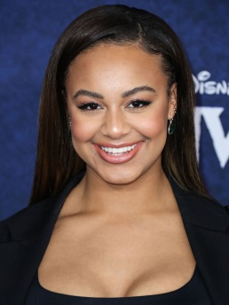
Instagram is launching a live shopping event today through Dec. 15 via the Shop tab, following a similar live shopping event series in September. Nia Sioux, Lisa Rinna and other celebrities will offer curated gift selections and special offers with brands such as Urban Outfitters, Alo Yoga and BlendJet.
Social Media Today 12.6.21
https://www.socialmediatoday.com/news/instagram-launches-new-series-of-live-shopping-events-for-the-holidays/611032/
Image credit:
https://www.hawtcelebs.com/wp-content/uploads/2020/02/nia-sioux-at-onward-premiere-in-hollywood-02-18-2020-6.jpg

