Instagram Favored Among US Content Creators
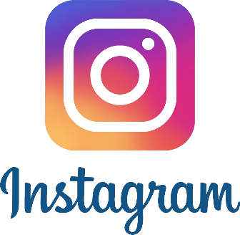
At least 98% of US creators use Instagram posts, Stories and Reels for sponsored content, with TikTok (89.6%), Instagram Live (69.1%) and Facebook (68.9%) next among top post types, Mavrck reports. While Instagram still is preferred for influencer marketing, TikTok's algorithm is attracting emerging and video-first creators because it "allows them to build audiences more easily than on other channels," writes Alexandra Samet.
Insider 8/28/23
https://www.insiderintelligence.com/content/us-creators-opt-instagram-despite-reels-revenue-concerns

