Instagram Joins Rising QR Code Trend
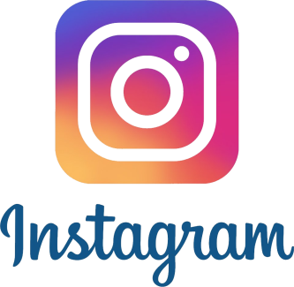
Instagram is launching an in-app scannable QR code tool globally that can be read by third-party camera apps and enable users to access company information, follow an account or purchase products. Research predicts QR code scans will reach 5.3 billion by 2022 as more businesses implement the technology as a contactless ordering and payment tool, writes ModernRetail's Gabriela Barkho.
The Verge 8.18.20
https://www.theverge.com/2020/8/18/21372322/instagram-qr-code-launch-global-nametag

