Google, YouTube Launch Interactive Mobile Marketing Tools
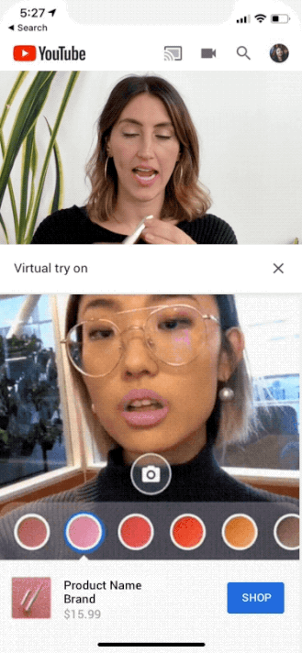
Google-owned YouTube is testing AR Beauty Try-On, a tool for the app that enables individuals watching makeup review videos to see themselves glammed up with products such as lipstick via their own front-facing cameras. Google is also launching Swirl for mobile, a 360-degree display ad format with animation, rotate and zooming features, along with another format that enables brands to run live YouTube streams in display ads.
TechCrunch 6/18/19
https://techcrunch.com/2019/06/18/youtubes-new-ar-beauty-try-on-lets-viewers-virtually-try-on-makeup-while-watching-video-reviews/

