Internet Caps Make Streaming More Costly Than It Seems
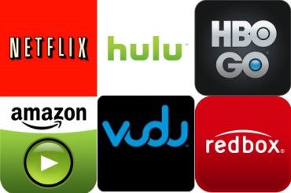
Some consumers are getting a rude awakening when they open their cable bills after binging their favorite shows and movies on streaming services like Netflix or Disney+, writes Jefferson Graham. The autoplay feature can easily take viewers past many internet providers' one-terabyte data limit, even when they turn off their televisions.
USA Today 12/3/19
https://www.usatoday.com/story/tech/2019/12/03/netflix-hulu-disney-plus-look-out-for-hidden-streaming-charges/2588606001/
Image credit:
https://www.springhappenings.com/sh_content/uploads/2016/04/streaming.jpg

