Internet-Only Viewing is Coming Soon, says BBC
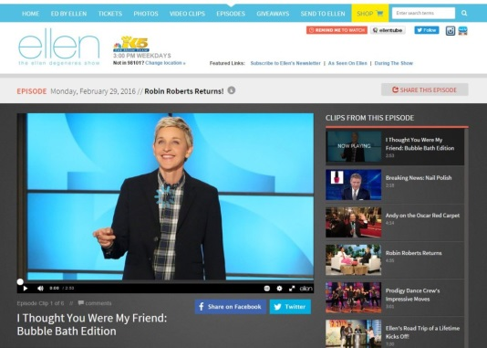
The BBC's recent annual company report states that online-only video accounts for 25% of young people's consumption, up from 5% a few years ago. The rise in online content consumption is fueled by providers such as Netflix, which is now accessible in 200 countries, and traditional TV providers such as CBS planning growth of streaming options, writes Alex Weprin.
MediaPost Communications 4/9/18
https://www.mediapost.com/publications/article/317259/ott-takeaways-from-the-bbcs-annual-report.html
Image credit:
https://exstreamist.com/wp-content/uploads/2016/03/streaming-ellen-online-1024x732.jpg

