SAG-AFTRA Unveils Standards Protocols for Intimacy Coordinators
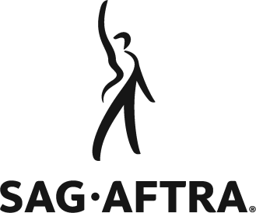
SAG-AFTRA said it believes that implementation of these standards and protocols will allow productions to run more efficiently, provide a safety net for performers and establish specialized support that empowers both cast and crew.
TVNewsCheck 1.29.20
https://tvnewscheck.com/article/more-news/243977/sag-aftra-unveils-standards-protocols-for-intimacy-coordinators/?utm_source=Listrak&utm_medium=Email&utm_term=SAG-AFTRA+Unveils+Standards+Protocols+For+Intimacy+Coordinators&utm_campaign=Local+OTT+Ad+Sales+Gaining+Traction

