Journalist Combat Deaths Up
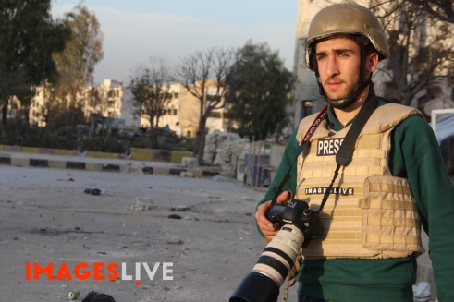
Deaths in combat or crossfire ticked to their highest number since 2013 as conflicts in the Middle East dragged on. More than half of the journalists killed in the year died in combat or crossfire, for the first time since CPJ began keeping records.
Committee to Protect Journalists 12.19.16
https://cpj.org/reports/2016/12/journalists-killed-murdered-syria-most-deadly-war.php

