86% Of Journalist Killings Go Unpunished
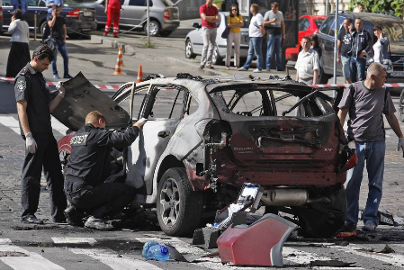
No punishment results 86% of the time journalists are murdered, a rate that UNESCO called "unacceptably high" in its recent report marking the International Day to End Impunity for Crimes Against Journalists. The agency adds that 117 journalists were killed because of their work in 2020 and 2021.
Manila Standard (Philippines)/Agence France-Presse 11/2/22
https://manilastandard.net/news/314274711/most-murders-of-journalists-go-unpunished-unesco.html
Image credit:
https://s.wsj.net/public/resources/images/BN-OZ800_ukr101_J_20160720082558.jpg

