Journalists Brave Danger To Cover Invasion Of Ukraine
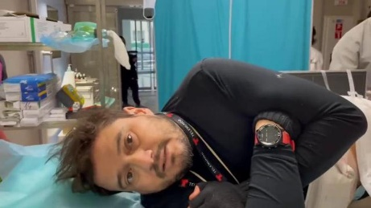
Russian threats and the risk of injury or death are not stopping journalists from covering Russia's invasion of Ukraine and the toll it is taking on civilians. At least two journalists have been killed while covering the conflict, including Fox News cameraman Pierre Zakrzewski, and the Committee to Protect Journalists reports that Russian forces are detaining and deliberately targeting news crews -- an act that could constitute a war crime under international laws.
Axios 3.15.22
https://www.axios.com/russia-ukraine-war-journalists-dangers-2ec97a55-0dc2-4f71-bdef-05dfeb97022b.html
Image credit:
https://i0.wp.com/www.ruetir.com/wp-content/uploads/2022/03/Who-is-Brent-Renaud-the-American-journalist-killed-in-Ukraine.jpg

