Journalists Rally to Defend Themselves from Police
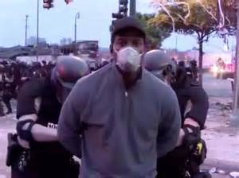
Two journalism groups have joined to form the Legal Advocacy Initiative for Journalists, which will help with defenses for those injured or arrested during the ongoing protests against police brutality and racism. Journalists across the country are also speaking out about why coverage of these events is essential, even while police assault them with teargas, concussion grenades and other weapons.
Nieman Journalism Lab 6.5.20
https://www.niemanlab.org/2020/06/two-press-freedom-groups-are-joining-forces-to-offer-legal-assistance-to-journalists-arrested-or-injured-covering-new-stories/

