Journalists’ Most Urgent Training Needs are Mobile, Data and Video
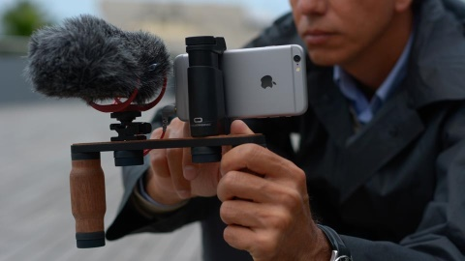
Respondents say they’d try bite-size lessons on their phone to learn digital skills. Three-fourths of respondents to a June survey about digital-journalism training said they would likely try learning such skills on their phone in bite-size lessons. The skills they most urgently want to learn are related to mobile, data and video journalism.
Reynolds Journalism Institute 8.23.17
https://www.rjionline.org/stories/survey-journalists-most-urgent-training-needs-are-mobile-data-and-video?utm_source=API+Need+to+Know+newsletter&utm_campaign=e185aeff3e-EMAIL_CAMPAIGN_2017_08_29&utm_medium=email&utm_term=0_e3bf78af04-e185aeff3e-31697553
Image credit:
http://www.iphon.fr/public/Teza/2016/T2/iphone-reporter-interview-2.jpg

