Judge Dismisses Most Music Publishers' Claims Against X
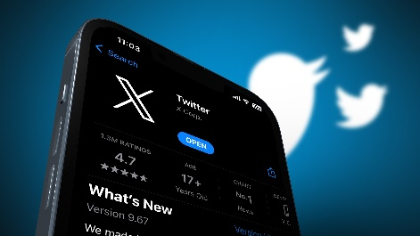
A copyright infringement lawsuit brought by 17 music publishers against Elon Musk's X has been mostly dismissed by a US district court judge, who rejected all claims except one that the social media platform failed to act quickly on takedown notices or police repeat offenders. The labels claimed X violated copyrights by allowing users to post songs online without permission, but the judge ruled X could not be held financially liable for its customers' actions.
Reuters 3/6/24
https://www.reuters.com/legal/elon-musks-x-escapes-most-lawsuit-over-copyrighted-songs-2024-03-05/
Image copyright:
https://www.searchenginejournal.com/wp-content/uploads/2023/08/x-twitter-brand-safety-innovations-64d2d7742a3c1-sej.jpg

