Kai Cenat Charged With Inciting A Riot Due To NYC Giveaway
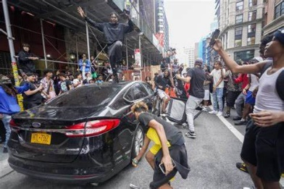
The NYPD said Cenat had not gotten a permit to host the event, and that the crowd grew “exponentially” and was “uncontrolled.” Videos from the event show people climbing on cars and buses. Officers arrived in riot gear, and claimed there were no shots fired and no flash-bang devices used. One video, though, showed officers grabbing an attendee who was walking away, swinging him around, and pushing him face first into the back window of a taxi, which shattered and cut him.
Tubefilter 8.7.23
https://www.tubefilter.com/2023/08/07/kai-cenat-charged-new-york-city-giveaway-riot/
Image credit:
https://internewscast.com/wp-content/uploads/2023/08/Kai-Cenat-a-Social-Media-Influencer-Accused-of-Inciting-Riot.jpg

