Knight Prototype Projects will Tackle Fake News
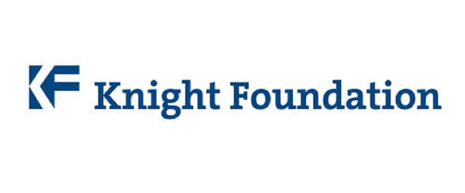
The Knight Prototype Fund announced a round of 20 new initiatives, all of which are addressing in some way ongoing concerns about trust in news (including the fake kind), media literacy, and fact-checking.
Nieman Lab 6.22.17
http://www.niemanlab.org/2017/06/the-latest-class-of-knight-prototype-projects-will-tackle-trust-media-literacy-and-yes-fake-news/?utm_source=Daily+Lab+email+list&utm_campaign=58cabc33ac-dailylabemail3&utm_medium=email&utm_term=0_d68264fd5e-58cabc33ac-396123901

