Understand L.A.’s Past Through Times Archival Photos on Instagram
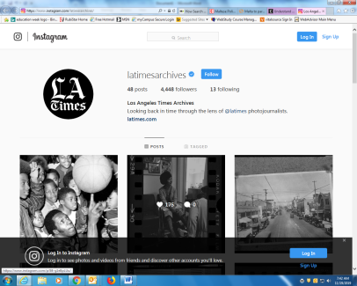
The Los Angeles Times has a new account on Instagram dedicated to archival photos. The account — @latimesarchives — showcases decades of photos from Los Angeles, the West, and around the world. Our archival content has consistently been among the most engaging images on our main @latimes Instagram account, so we’re expanding that interest into a standalone account.
Los Angeles Times 11.14.19
https://www.latimes.com/california/story/2019-11-14/archives-instagram-account?utm_source=Daily+Lab+email+list&utm_campaign=9c0409a230-dailylabemail3&utm_medium=email&utm_term=0_d68264fd5e-9c0409a230-396123901
https://www.instagram.com/latimesarchives/

