Lake Charles Stations Back To Full Strength
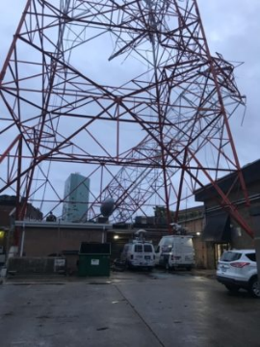
A group of six stations in Lake Charles, La., have finally rebuilt after a couple 2020 storms impinged upon their operation. The stations shared resources over the last two years, and company representatives mentioned finding a construction crew at one point was especially difficult.
Radio World 6/28/22
https://www.radioworld.com/news-and-business/slammed-by-storms-a-cumulus-cluster-rebuilds?utm_source=SmartBrief&utm_medium=email&utm_campaign=45863C53-9E40-4489-97A3-CC1A29EF491D&utm_content=0563D146-1B6E-435D-BE3B-17F3614CE483&utm_term=a25693a1-51b6-4112-bde4-56bd420e983f
Image credit:
https://www.rbr.com/wp-content/uploads/IMG_07395-315x420.jpg

