Lawmakers' Support For In-Dash AM Continues To Climb
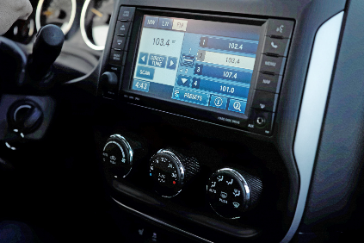
Four more members of the US House of Representatives have signed on to back the proposed AM Radio for Every Vehicle Act, bringing support for the bipartisan-backed legislation to 200. "AM radio continues to reach a vast audience of 82 million listeners each month, and they are very engaged and have been vocal in telling Congress how important this medium is to them in light of the threat by automakers to remove AM from vehicles," says National Association of Broadcasters' Alex Siciliano.
Inside Radio 1/17/24
https://www.insideradio.com/free/support-for-am-in-auto-dashboards-hits-200-in-the-house/article_58697072-b510-11ee-abba-e7e69399b4c1.html
Image copyright:
https://images.squarespace-cdn.com/content/v1/55d4d391e4b0a5b20384187f/1472492719447-2J6CKV4OZQPGR3K4415X/sirius-xm-satellite-radio-audiosport-San-Diego-stations-channels-siriusxm

