Lessons From Brands on Social Meme Success
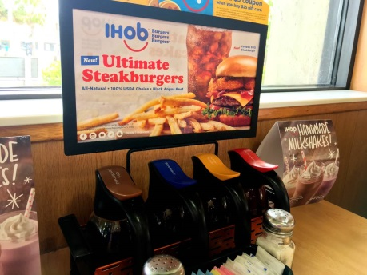
Brands have unintentionally or intentionally found themselves at the center of viral social memes, such as IHOP's rebrand to IHOB, which resulted in confused outrage, and Balenciaga's intentional creation of clothing that costs a fortune to inspire memes from its audience. Michelle Greenwald offers tips on how advertisers can win in the risky meme world, including demonstrating an understanding of pop culture, their audience and, most importantly, their sense of humor.
Forbes 3/14/19
https://www.forbes.com/sites/michellegreenwald/2019/03/14/how-memes-are-helping-and-hurting-brands-maximizing-the-upside-and-minimize-the-downside/#6e4636c92a1a
Image credit:
https://www.miamiherald.com/latest-news/e30m5n/picture213071164/alternates/FREE_1140/iHob%20syrup.jpg

