LGBTQ Diversity On Kids TV Growing
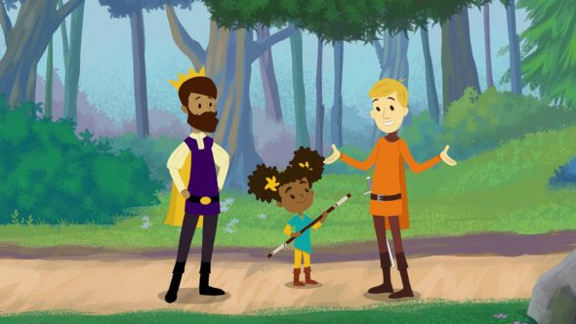
Zeke Stokes, chief programs officer for the media monitoring nonprofit GLAAD, said the struggle for inclusion has become easier as a number of LGBTQ writers and producers have made their way into positions of influence, though they're still a fraction overall.
TVNewsCheck 7.31.19
https://tvnewscheck.com/article/top-news/237370/bandwagon-builds-for-lgbtq-diversity-on-kids-tv/?utm_source=Listrak&utm_medium=Email&utm_term=LGBTQ+Diversity+On+Kids+TV+Growing&utm_campaign=Newsy+Pushes+Forward+As+Rivals+Falter
Image credit:
https://tvseriesfinale.com/wp-content/uploads/2019/05/the-bravest-knight-1-590x332.jpg

